Using Cloud Credits with Google AI
Author: Eric ShangKuan

tl;dr; this doc illustrates examples to use cloud credits with Google’s vibe coding tools

Scenarios I - Demonstrate the latest pro models

1.1 Using Gemini 3.1 Pro, Nano Banana and other paid models API / Playground
Summary - In Google AI Studio, free tier API keys can be only used on the Gemini 3 Flash model. If you want to let the attendees try the Gemini 3.1 Pro model (or Nano Banana Pro/2 models), use Vertex AI Studio instead.

Steps
- Go to Google Cloud console, create a project and use the billing account created by the Cloud Trial Billing.
- Go to Vertex AI Studio, you have to agree to the terms and enable Vertex AI API to continue if it’s your first time on Vertex AI Studio.
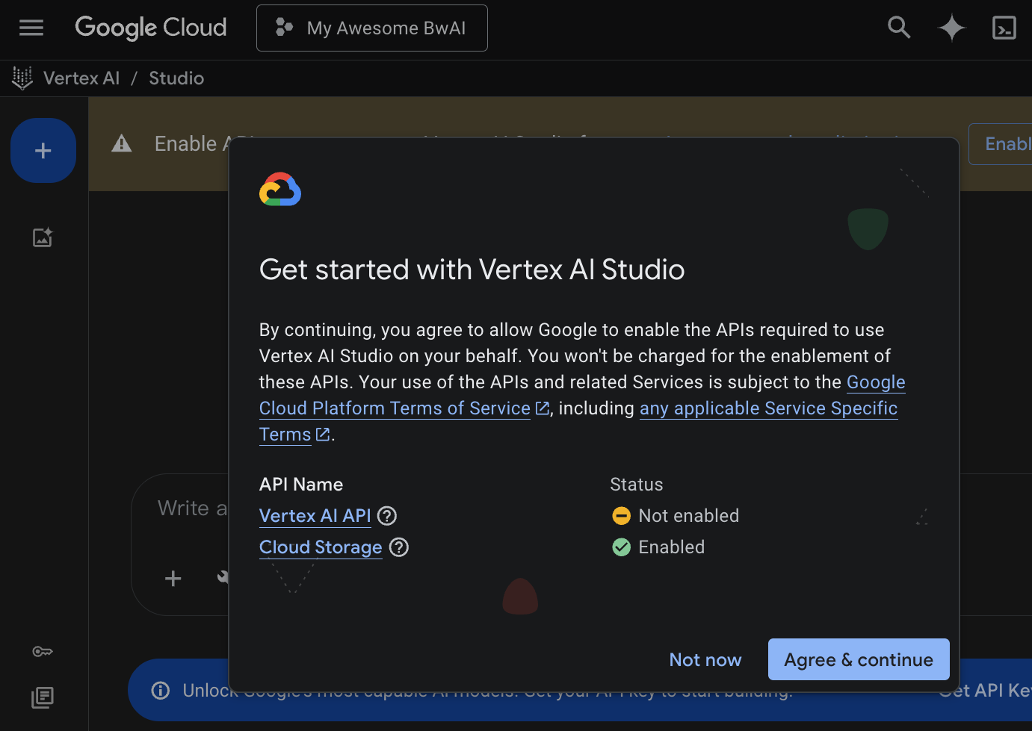
  - Don’t forget to enable Vertex AI API. Vertex AI Studio will prompt on the top.
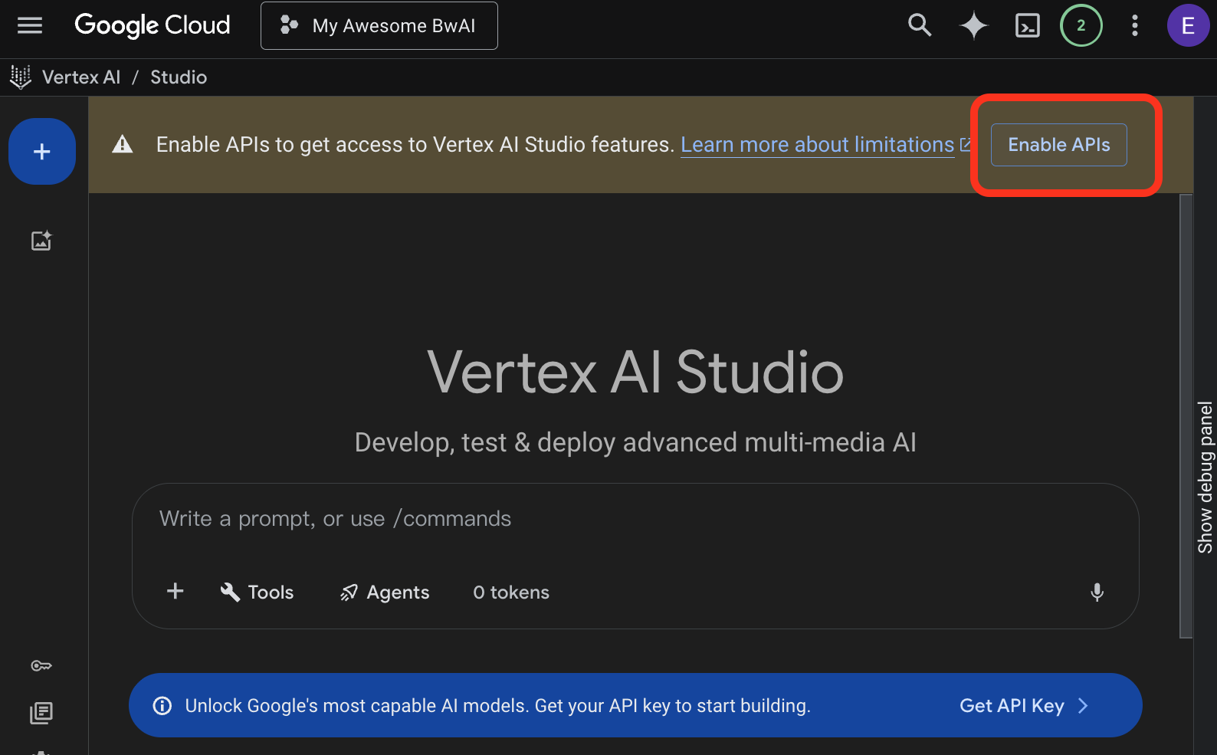

- Use the Model settings on the right panel to select the Gemini 3.1 Pro model. Use the interactive chatbox to continue.
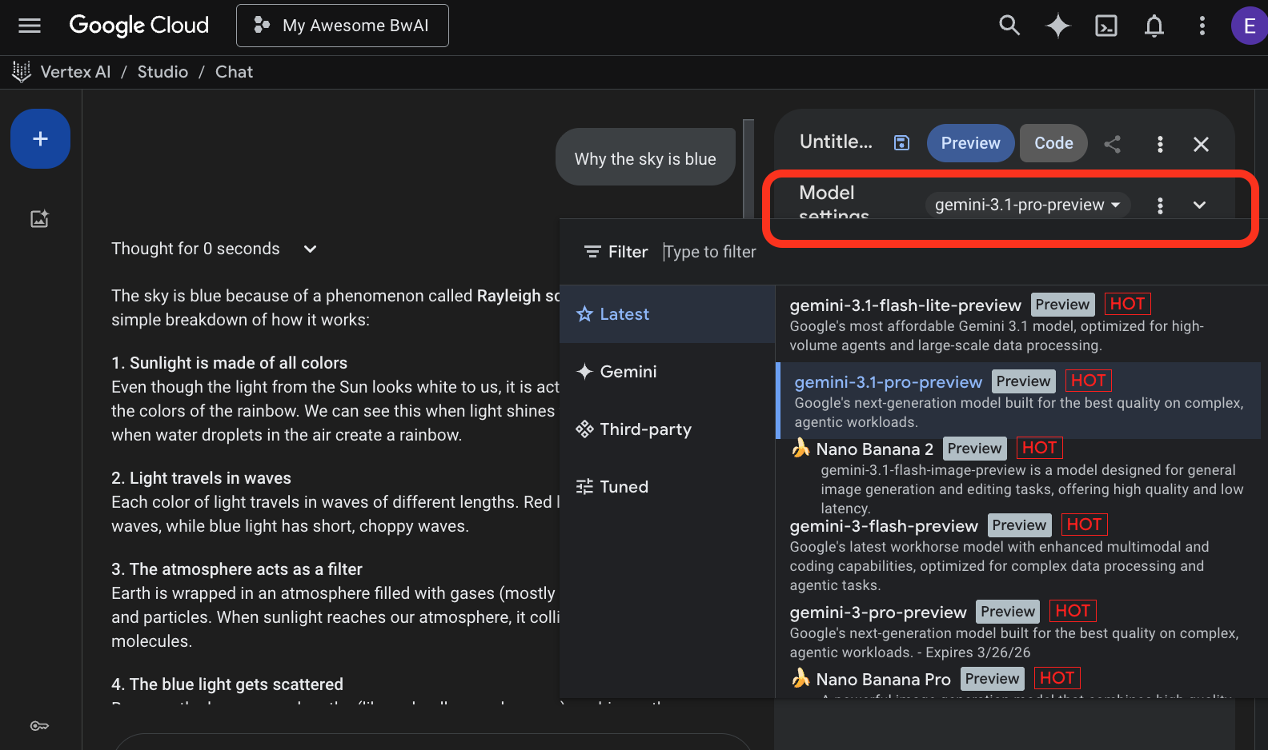

- Here is the Nano Banana 2 sample from the prompt gallery.
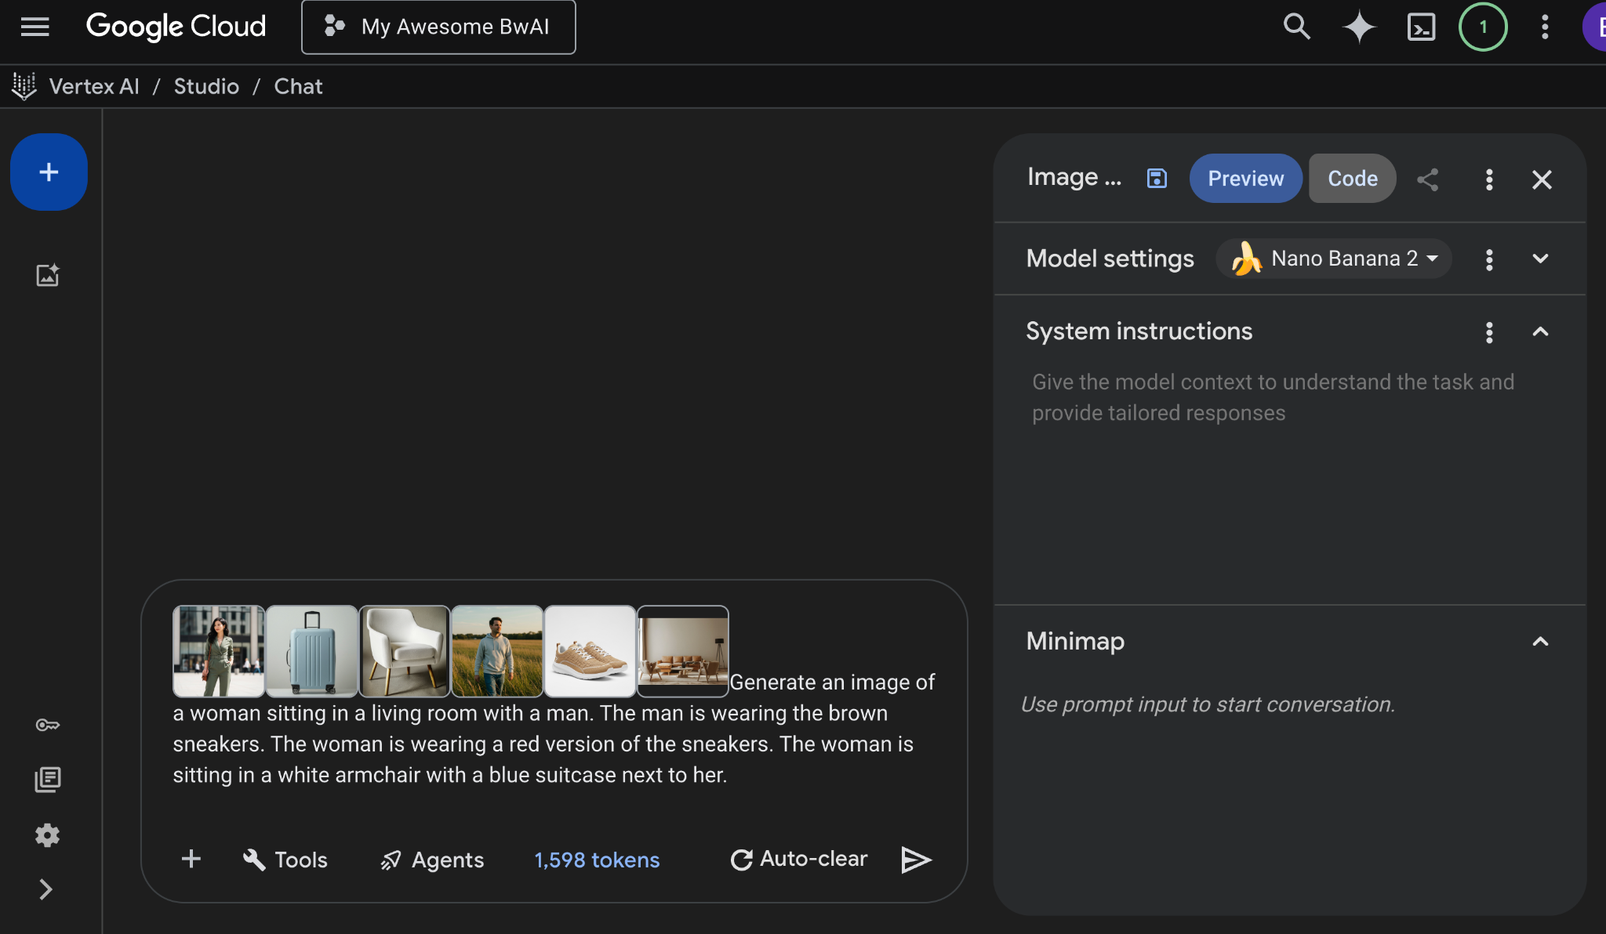

1.2 Using Pro models via Gemini CLI
Summary - Gemini CLI attendees can only use free tier either signing in Google account or Gemini API key. To use Cloud Credit, we may guide attendees to use Vertex AI to authenticate Gemini CLI.

Steps
- Create a project on GCP and enable Vertex AI API for the project.
- Create an API Key in Vertex AI Studio
- Setting the following environment variables
GOOGLE_CLOUD_PROJECT=<YOUR_PROJECT_ID>
GOOGLE_API_KEY=<YOUR_API_KEY>
- Select Vertex AI in the authentication page when you start Gemini CLI first time, or use /auth command if the attendees have
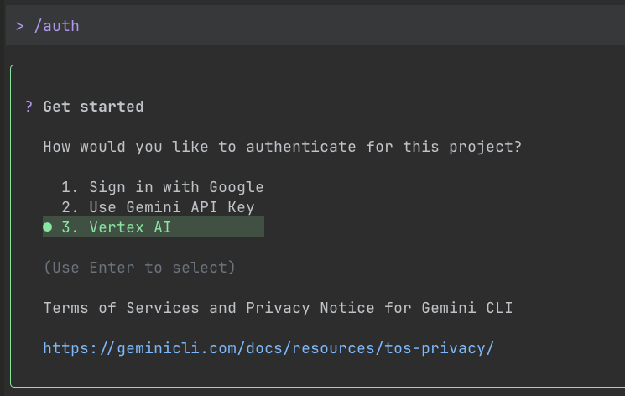

- Once setup is complete, the Gemini CLI will be ‘pay-by-usage’ mode and charge to the billing account created by the Google Cloud Trial Billing.

1.2.1 Using Gemini CLI in Google Cloud Shell
TBW

1.3 Using Pro models via API
Summary - Since Cloud credits (same as Trial credits) have been seen as free tier in Google AI Studio, use API via Vertex AI instead

Step
- Create a project on GCP and enable Vertex AI API for the project.
- Reference the notebook Intro to Gemini 3.1 Pro or Gemini 3.1 Flash Image (Nano Banana 2 🍌) Generation on Vertex AI to understand how to invoke Gemini 3.1 Pro / Nano Banana 2 API via GCP project.

Scenario II - Vibe Coding

2.1 Vibe Coding using Google AI Studio
Summary - Since Cloud Credits credits (same as Trial credits) have been seen as free tier in Google AI Studio, it cannot be used in model usage. However, we may guide attendees to deploy their vibe-coded app on to Cloud Run.

Steps
- Use free tier to do vibe coding in Google AI Studio Build, click Publish button to start publishing the app.
- Create or import GCP project from Google Cloud
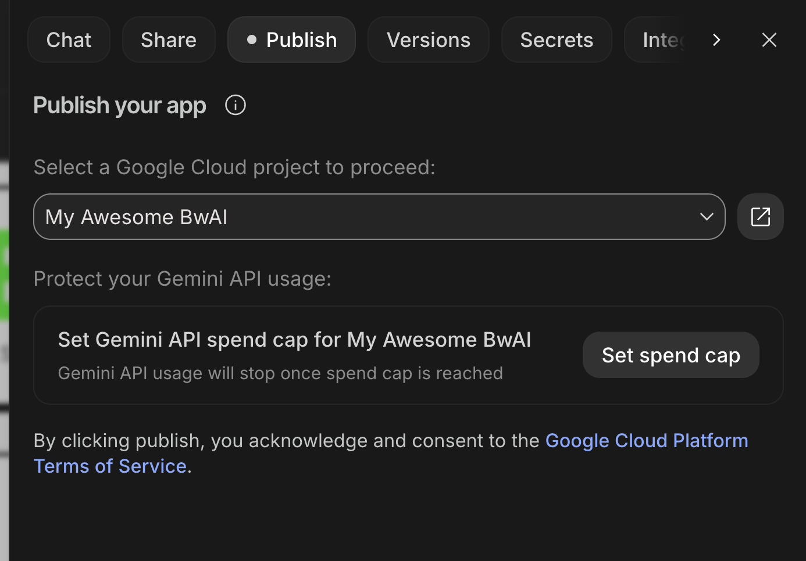
  - You may also setup the spend cap if you’re afraid of running out of the credits.
- Once the publish process is complete, the developers will get an URL to access their app.

2.2 Vibe Coding using Gemini CLI
Summary - Free tier users can use flash models in Gemini CLI. We may support them by 1) user Vertex AI authentication to unleash the pro models. 2) guide them deploy the vibe-coded app to Cloud Run.

Steps
- [Optional] Setting up the Gemini CLI to use Vertex AI authentication [See 1.2].
- Install the Cloud Run MCP Server extension in Gemini CLI.
  - Use the command
gemini extensions install https://github.com/GoogleCloudPlatform/cloud-run-mcp
to install the extension.
  - Set up the GCP project id and location.
  - Use the command gcloud auth
- Install Google Cloud SDK
- Setup Cloud Run MCP Server
  - Use the command to login GCP
gcloud auth login
  - Use the command to set up application credentials
gcloud auth application-default login
- Do vibe coding in Gemini CLI
- Once the vibe-coded app is ready to deploy, use the following prompt to deploy to Cloud Run
Deploy this folder as Cloud Run service in the project <project-id> in <gcp region> region.

2.3 Vibe Coding using Google Antigravity
Summary - developers can use Antigravity for free. In the Build with AI events, we may guide them deploy the app to Google Cloud Run.

Steps
- Add Cloud Run MCP Server in Antigravity.
  - Open the … menu in the Agent Manager and click MCP Servers.
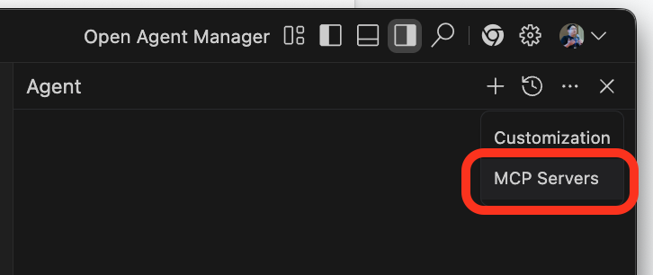
  - Search and Install Cloud Run in the MCP Store
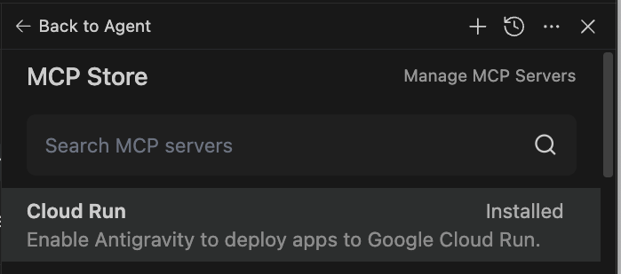

- Do vibe coding in Antigravity.
- Once the vibe-coded app is ready to deploy, use the following prompt to deploy to Cloud Run
Deploy this folder as Cloud Run service in the project <project-id> in <gcp region> region.

